Women veterans at higher risk for repeat suicide attempts than men, OHSU study suggests

By Gemma DiCarlo (OPB)
July 15, 2024 9 a.m.

Broadcast: Monday, July 15
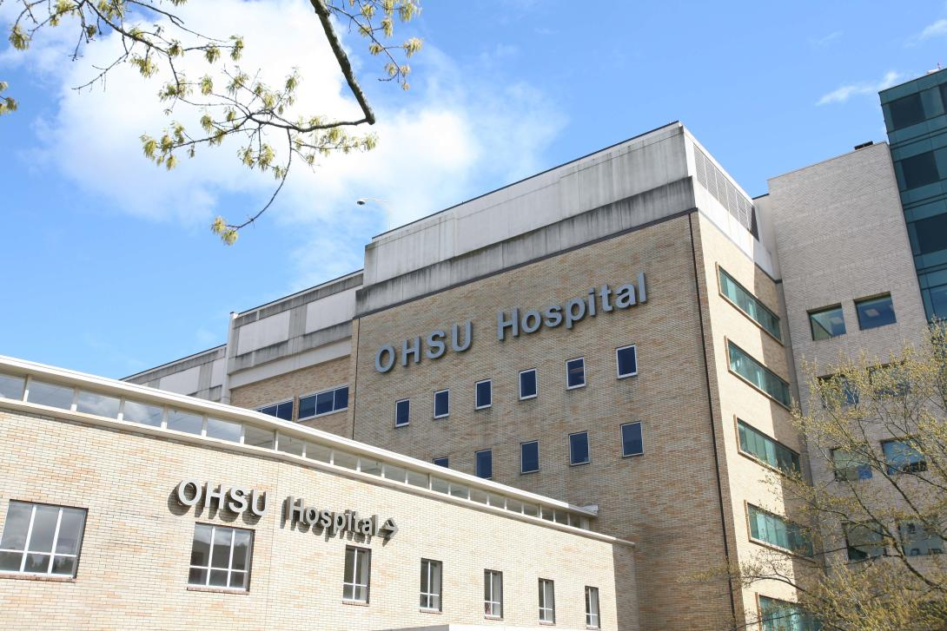
Undated file photo of Oregon Health & Science University.
Courtesy of Michael McDermott / OHSU
According to the Centers for Disease Control & Prevention, veterans have a 57% higher risk of suicide than the general population. But little is known about how that risk differs between men and women who have served. In the first study of its kind, researchers at Oregon Health & Science University followed a group of veterans for roughly a year after a nonfatal suicide attempt. They found that the women who were surveyed reported more social rejection and lower levels of self-compassion than men, suggesting a higher risk of another attempt.
Lauren Denneson is a professor of psychiatry at OHSU and associate director of the Center to Improve Veteran Involvement in Care at the VA Portland Health Care System. She is the lead author of the study and joins us with more details.
Note: If you’re a veteran in crisis or concerned about one, contact the Veterans Crisis Line to receive 24/7 confidential support. There are several ways to reach responders, and you don’t need to be enrolled in VA benefits or health care to access them. You can dial 988 then press 1, text 838255 or chat online at VeteransCrisisLine.net/Chat
In general, if you or someone you know may be considering suicide, contact the Suicide and Crisis Lifeline by dialing 988, or the Crisis Text Line by texting HOME to 741741.

Contact “Think Out Loud®”

